Two Dynamic Process Models of Covid-19 with Divergent

Vaccination Outcomes

Ernie Chang, MD PhD, Ken Moselle, PhD

January 24, 2021

**INTRODUCTION**

The CovidSIMVL agent-based simulation system is a flexible generator of model Covid-19 epidemics, grounded in viral temporal dynamics from Xi, He {Nature Medicine Aug 2020] using a physical contagion approach with parameters of size and activity.

The parameters of Hazard Radius {“HzR”), Mingling Factor (“mF”), and Symptomatic Days (“Red Days”), within the stochastic approach to agent movement and viral growth, allows CovidSIMVL to generate simulated epidemics of varying dynamics for a single “Fixed Universe” or for interacting multiple Universes in which sub-populations can move from one Universe to another according to deterministic schedules.

In this paper, we introduce two dynamic process approaches to Covid-19 epidemics, and then a population structured by age groups, for which vaccination schedules are simulated. The different outcomes from the two dynamics in terms of vaccination protection will be described.

**WAVE vs PARTICLE Dynamic Processes**

By setting parameters to favour locality of movement for the agents, their HzR (the larger, the more likely two agents will make contact following a cycle of moves), and the duration that Symptomatic Cases remain in circulation, we can model Covid-19 simulated epidemics at different ends of a spectrum.

**METHODOLOGY**

***WAVE Dynamics***

The parameters for the WAVE trial were set to the following:

Population 1,000

HzR 2.1

mF 0.95

“Red days” [8.2] symptoms start at day 5.2 from infection – this is net 3 days

The model dynamics, because of the low mF, constrain the agents to remain close to their locality (despite the stochastic Pareto-like distribution of probable moves), and produce configurations like these:

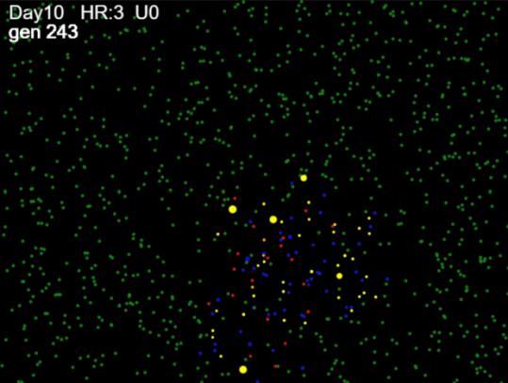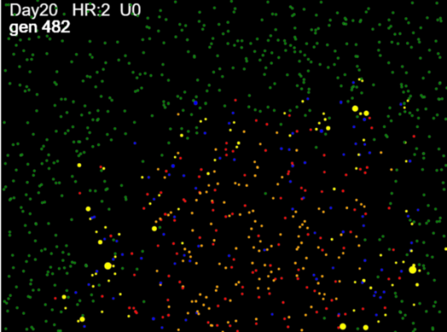

The population of 1,000 is distributed randomly at initialization, and we start with a single infected agent, placed randomly. If the position happens to be in a corner, the contagion spreads like a wave-front; and if the initial position is more central, then the wave front tends to be radial.

We have set parameters, through trial and error, to fully infect (with stochastic margins of error) the entire population. The notion here is not that the study population is the entire population; rather, we would in the scenarios, focus on the 1,000 cases that would be infected. The simulations are not framed to include those who would not be infected. Mitigation, vaccinations are intended to produce positive effects on those who would otherwise not be saved.

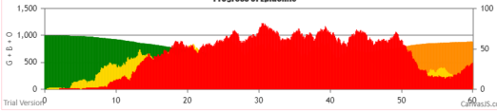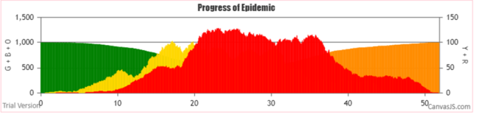The dynamics of this progressive “Wave” like movement of the contagion also produces interesting growth charts, seen below as typical cases per day epidemiology graphs.

The red represents the daily counts of Symptomatic Cases; Greens are susceptibles, and Yellows are Incubating; Orange are agents that have gone beyond the symptomatic days and are now inert.

***PARTICLE Dynamics***

By setting the mF high, and keeping the HzR low, the simulation processes cause agents to move in large jumps within the virtual arena. Thus, contacts and infections more closely resemble the mass action assumptions of equation based epidemiology models. The virtual arena appears as below.

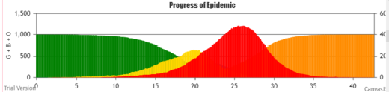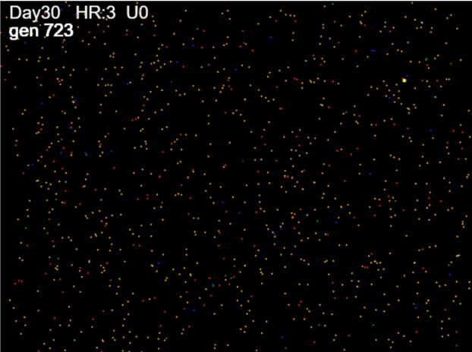

Despite the tiny dots of color, it is obvious that the agents in various states are distributed randomly. Furthermore, the distribution of the symptomatic cases fits perfectly (almost) into a symmetrical Bell shaped curve.

The parameters for this trial were: HzR 1.3, mF 7.5, and Red Days 9.9. This trial ended with zero survivors, in 1024 generations (each generation is considered an hour, and changes are made every generation).

The WAVE Simulation ended at Gen 1246 (51 days and 22 hrs), with 2 survivors out of 1,000.

**RESULTS**



The metric theta.all refers to “theta” as TIME/#infections. For any period, this gives the average time between infections, which is a measure of the aggressiveness or speed of the epidemic. Here, theta.all refers to the total time to the last infection divided by the number of infections.

The rate for WAVE is 1.05 generations between infections, while for PARTICLE it is 0.79 generations per infection. This is a quantification that can be applied to any time interval.

***Console.log***

Through use of the console.log, the CovidSIMVL program is able to produce a trace of every infection, its time (in generations), and other state information, as seen below.



From this chronology, we created frames of 60-generations starting at generation 300 (approximately Day 12.5), and within each frame, counted the number of infections that occurred. There is some delay and merging between the infection history and the chart, because the symptomatic cases stay around for 4.7 days in the PARTICLE model, and for 3 days in the WAVE model. However, we compare infections in what follows, rather than case per day as in the chart.



This table shows that the PARTICLE processes were more active in all 60-generation frames (more infections, more spread), but interestingly, the WAVE dynamics gave roughly the same number of infections in each frame, thus accounting for the plateau in the chart above.

The relationship between the truncated cone of the PARTICLE process and the WAVE can be visualized in the graph of the table above. It would appear that the cases from the top of the cone have been distributed over time in the WAVE scenario.

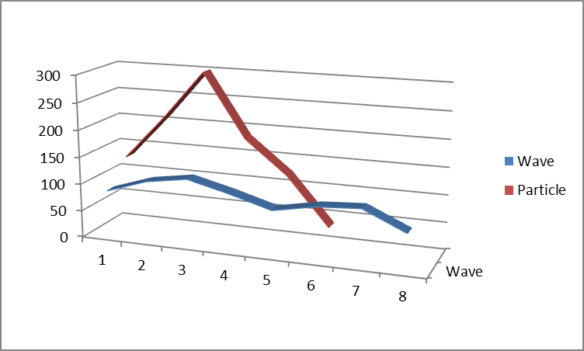

***Internal Dynamics of WAVE vs PARTICLE.***

In the table below, we show thetaNNN where NNN is the infection number. There are 1,000 agents in the population, and the console.log lists them in order of infection, along with the generation tag. Thus, for theta 100, we take the first 100 infections, identify the time of the first and last, thus finding the total elapsed time for this 100. Theta100 is then time/# which is elapsed/100.

Similarly, theta200 is in this table, used with local reference. In other words, instead of the total time from start to 200 infections, we use the time for the second 100 infections, and so on.



Each value of theta is the time/per infection, and the larger it is, the slower the epidemic. Since we start with only one infected person, the epidemic has to create more simultaneous infectors, so in both cases theta100 is a relatively large number.

In the case of WAVE, the theta values are pretty consistent between theta300 and theta800 at around 0.5 to 0.6. This is in contrast to PARTICLE, which in keeping with the Bell curve, decreases in theta to a low of 0.17 at theta600 and increases on each side, with theta values smaller (faster) than the comparable WAVE theta values in the same intervals.

The interesting observation here is that the exponential growth of the epidemic, which is reflected by the Bell curve, and is in keeping with the random infection assumption of equation-based modelling, may not hold if the process dynamics tend toward WAVE. There is a possibility inherent in these two models that the exponential growth can be replaced by polynomial growth, which extends the time and reduces the peak of the epidemic. WAVE conditions are simple: restricted movement of all agents.

**II. AGE-STRUCTURED POPULATION AND VACCINATION MODELING**

The capabilities of CovidSIMVL permits the system to specify the age-groups of the population, and to implement vaccination schedules for a percentage of an age group in a Universe. In this paper, we explore the effects of WAVE vs PARTICLE in a single Fixed Universe.

The population of 1,000 has been carefully tailored to reflect morbidity due to Covid in British Columbia, using 2020 Covid-19 data from Jan 15 to December 12, 2020.

***Age-Tables***



This is the data from British Columbia CDC for the period Jan 15 – Dec 12, 2020. We calculated the new column “Cases% AgeGp” by taking the “Cases n” for each ageGp as a percentage of the “BC Popn” by AgeGp.

We use this column to construct a new table of 1,000 cases in the following way. First we fix the total “Cases n” at 1,000. Then we use the “Cases % Total” to fill the new “Cases N” rows for each age group. Thus, for age group <10, from “Cases % Total” of 3.99% X 1,000 (total in “Cases n”) we get 40, and so on.

Next, we use the derived “Cases% AgeGp” to calculate the BC population. So, if 40 cases make up, from “Case% AgeGp”, 0.37% of the BC population, the BC population for the age group <10 would be 40/0.37% or 10,775, and so on for the other age groups.

We end up with the following table distributing the 1,000 patients into age-groups using “Cases n”.



This table is useful as the age structure is the same as the morbidity structure reported, but for 1,000 cases. This is the approach in which we want to set the parameters so that all 1,000 will be infected, and their subsequent hospitalization, ICU, and deaths follow from the known percentages.

With this population, studying the effect of vaccinations will allow us to understand not just the cases that may be spared, but also the consequent downstream hospitalizations, ICU and deaths.

***Vaccination Mode in CovidSIMVL***

In a previous paper, we discussed the different modes (one jab or two jabs) for the Pfizer, Moderna vaccines if they are followed to the EUA (Emergency Use Authorization) of the manufacturers, and the potentially favourable outcome of a hypothetical Hybrid vaccine.

In this version of CovidSIMVL, we have extended the user parameter selection to permit entering an age group and a percentage, applying to persons who are in the Universe at hand. The console.log records the vaccination and assigns it Mode 2 (two jabs).

The vaccine is assumed to be inactive for 14 days with no protection, then with 75% protection till day 28, after which the person has 95% protection. The vaccine’s efficacy is implemented at the time a contact has been detected between a viral carrier and a susceptible. If the random number drawn is greater than the threshold of protection, the viral transfer continues, otherwise the contact is nullified.

The vaccinated person is able to transmit at the same level as the protection given to a susceptible. In other words, if the random number drawn is greater than the threshold (say 95%) the transmitter may infect.

The console.log produces a trace of vaccination protected encounters, both on the susceptible and the receiving end.

**METHODOLOGY**

The vaccine trials with WAVE and PARTICLE are done with 100% of 90+ (18), 100% of 80-89 (33) and 100% of 70-79 (47) for a total of 98 persons vaccinated.

The trials terminate when no further infections are possible. The final status of all age groups is produced below for WAVE and PARTICLE.

An analysis of the status of the vaccinated populations (Gp9, 8 and 7) is produced by examining the theta values (time between infections) for these two groups in the WAVE vs PARTICLE framework, and compare the vax to the no vax trials from the first part of this paper.

**RESULTS**

From the trials, the summary results using the console.log are:



The group numbers are those who have survived. The terminations occurred when there were no more infectives. It can be seen that WAVE went on for longer. The R0s recorded were unremarkable at 2.26 for WAVE and 2.37 for PARTICLE. Since our purpose was to get 100% infection, these R0 values are not excessive.

The summary of cases saved from WAVE vs PARTICLE are:



***Theta for the four cases of WAVE vs PARTICLE***

Recall that theta is the measure of the average time between infections in a given period, and the higher this number, the slower the epidemic.



This shows clearly the effects that vaccination has on the dynamics of infection in the age groups. The more protection, the longer the time between infections. It is remarkable that WAVE without vaccination is still slower than PARTICLE with vaccination.

**DISCUSSION**

These simulations are scenarios, and their relationship to In Real Life is by no means predictive or assured. The extremes of PARTICLE are not going to be seen in most situations of public health measures taken seriously by the population.

Nevertheless, this kind of simulation capability permits the elaboration of possibilities in ways that cannot be realized IRL.

The next set of trials will use vaccination not of 100 persons, but of 50% of the population. At this high rate, it may be possible to identify whether strategies aimed at transmitters rather than at the vulnerable have significant advantages.

The benefits from WAVE vaccination in the study population of 1,000 can easily be carried over to the percentages that are hospitalized, go to ICU or suffer death from the tables generated. Since there are no cost estimates for these downstream events, we leave their elaboration to others.